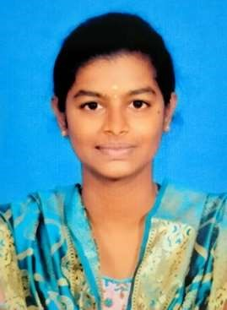

**HINDUMATHI R**

Contact : 8148027050

Address : 2/306, Nadustreet, Deevattipatti, Kadayampatti, Salem-636351

Mail Id : hindhuramesh8@gmail.com

LinkedIn ID : https://www.linkedin.com/in/hindumathi-r-95809226a/

# CAREER OBJECTIVE

Seeking a challenging position in a reputed organization where I can learn new skills, expand my knowledge, and leverage my learnings.

# ACADEMIC CREDENTIALS

|  |  |  |  |
| --- | --- | --- | --- |
| COURSE | INSTITUTION | YEAR OF  PASSING | CGPA/ PERCENTAGE |
| B.E – Computer  Science and Design | Karpagam  Academy of Higher Education | 2025 | 8.5 (Upto 5th Sem) |
| HSC | Ganga Kaveri Matric  Higher  Secondary School | 2021 | 79.04 |
| SSLC | Ganga Kaveri  Matric Higher Secondary School | 2019 | 74.2 |

# PROJECT

**TITLE :** Helpdesk Management System

**DESCRIPTION :** To develop a system for creating and managing online data of students and updating them using Artificial Intelligence.The Technology stack like Java , Python and MySQL

# INTERNSHIPS

* Undergone a virtual internship in Python Programming conducted by Pantech e Learning (2022).
* Undergone a virtual internship in Web Development Full Stack by Pantech e Learning(2023).
* Undergone a virtual internship in Artificial Intelligence by Whitehat Technology(2023).

# CERTIFICATION

* Certified in ‘Python Basics’ in Infosys Springboard by 2022.
* Certified in ‘Data Base Management System’ by NPTEL - 2023.
* Certified in ‘Introduction to Internet of Things’ by NPTEL – 2023

# TECHNICAL SKILLS

* C Programming
* Python (basic)
* HTML

# AREA OF INTEREST

* App Development
* Programming

# LANGUAGES KNOWN

* Tamil
* English

# HOBBIES

* Singing
* Dancing

# DECLARATION

I hereby declare that all the information provided above is accurate and true to the best of my knowledge.

# [HINDUMATHI R]